|  |  |
| --- | --- |
| Date | 11 November 2022 |
| Team id | PNT2022TMID49260 |
| Project Name | Hazardous area monitoring for industrial plant powered by IoT |

Node-Red

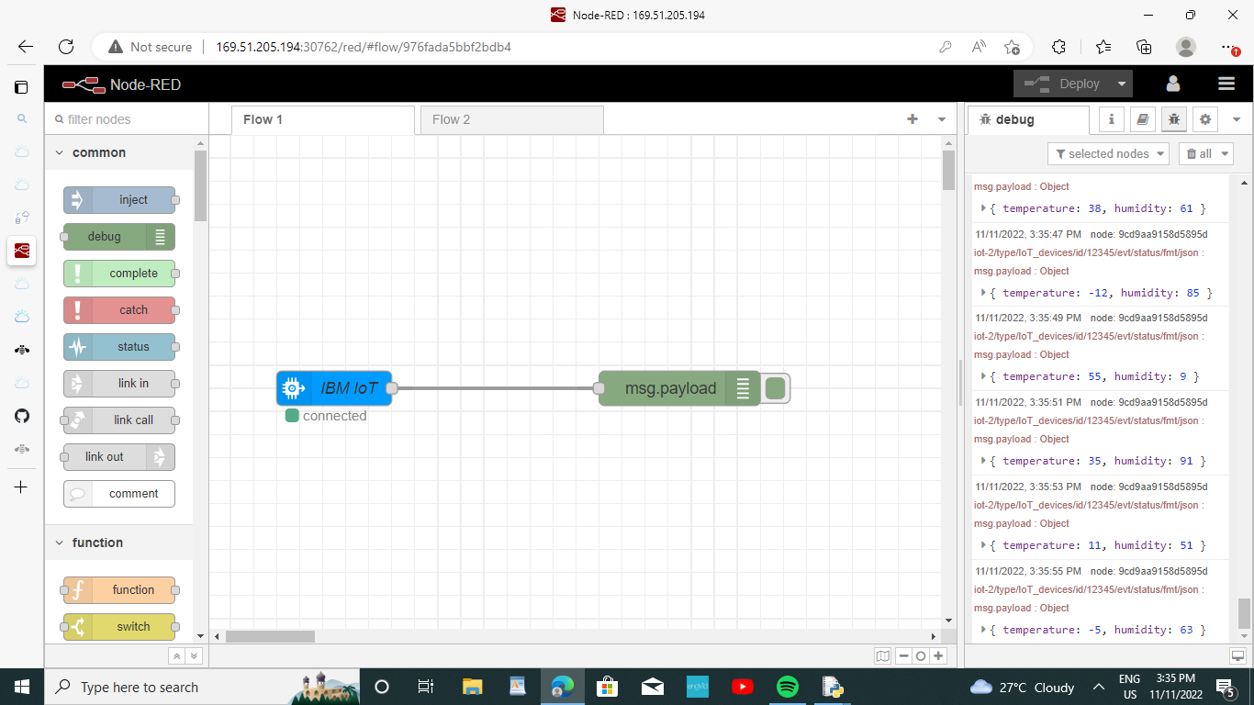

NODE-RED SERVICE CREATING SUCCESSFULLY